AUTHOR PORTFOLIO

Margaret Atwood

STEP1: Creating Navigation Pages using the Content Page.

AUTHOR PORTFOLIO BOOKS:

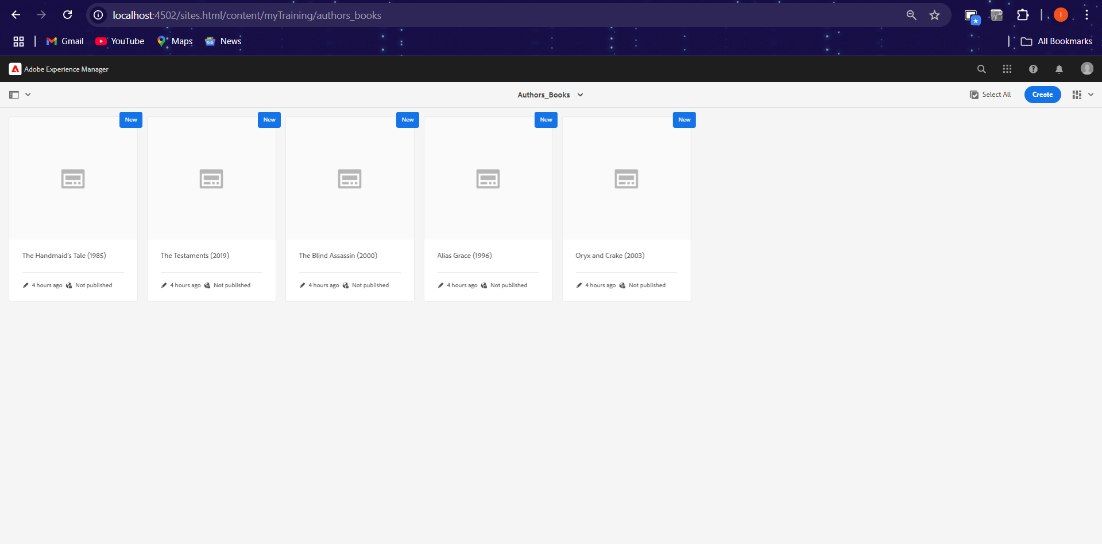

Margaret Atwood AWARDS:

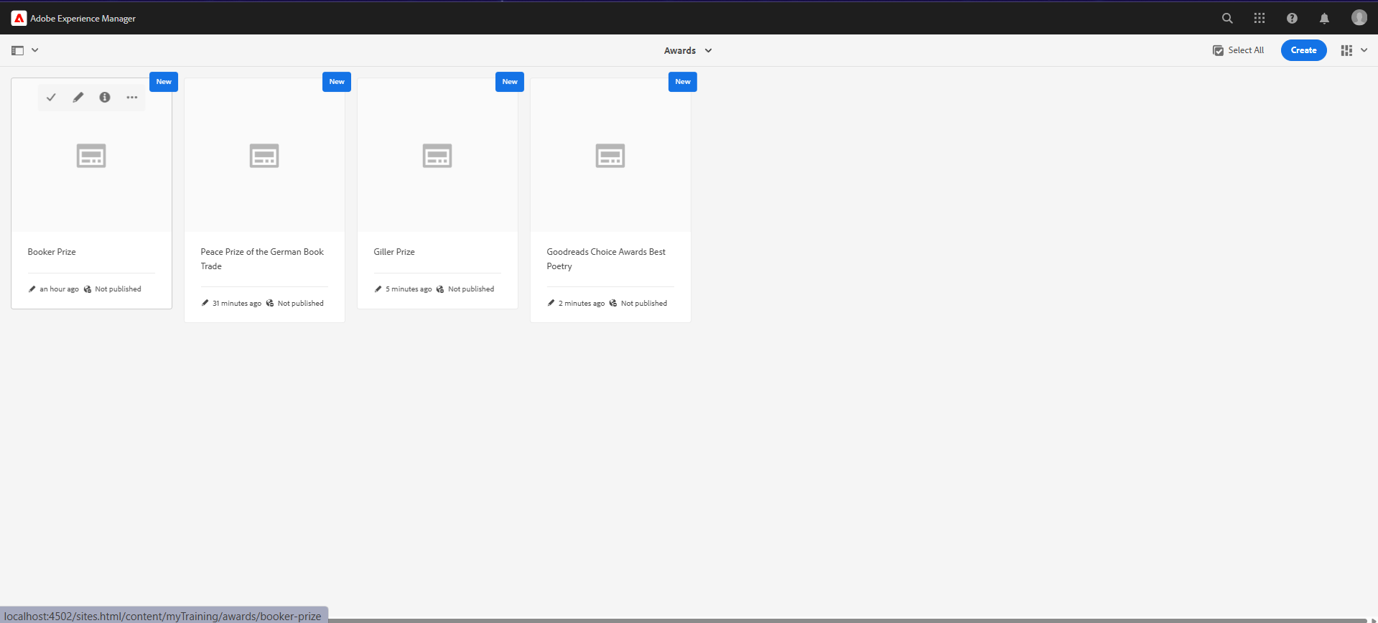

STEP2: Creating Template

AUTHOR PORTFOLIO TEMPLATE

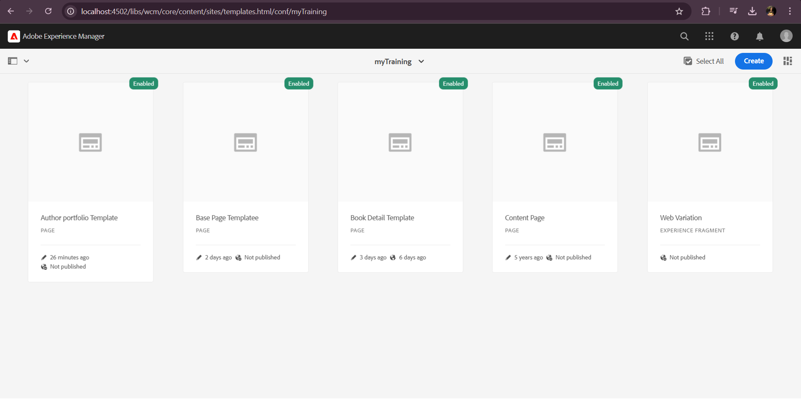

STEP3: Using the Template that we created , creating pages for the awards.



STEP4: Styling Header using Embed component.



STEP4: Styling Footer using Embed component.

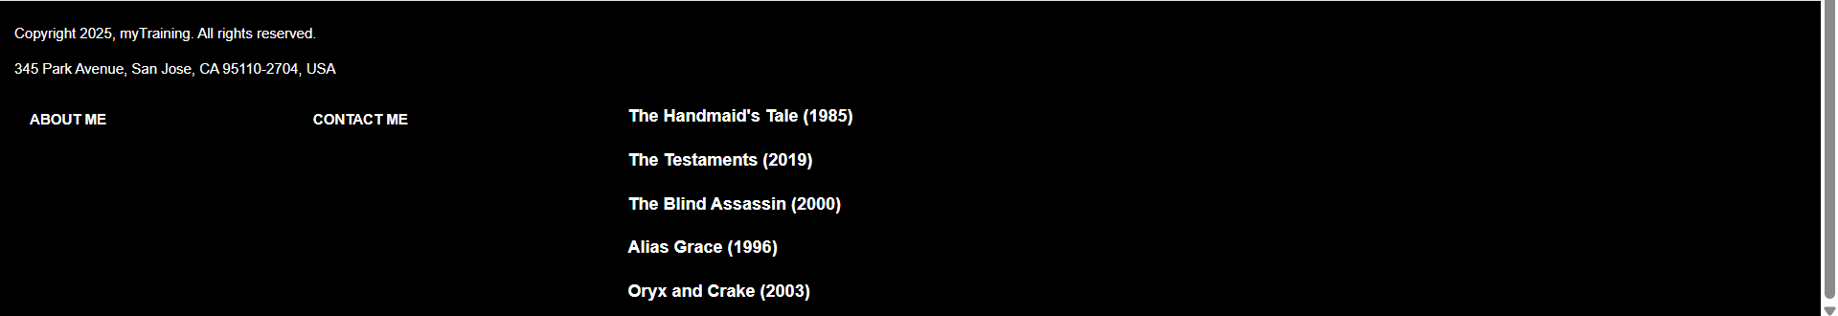

STEP5: Book Page Component

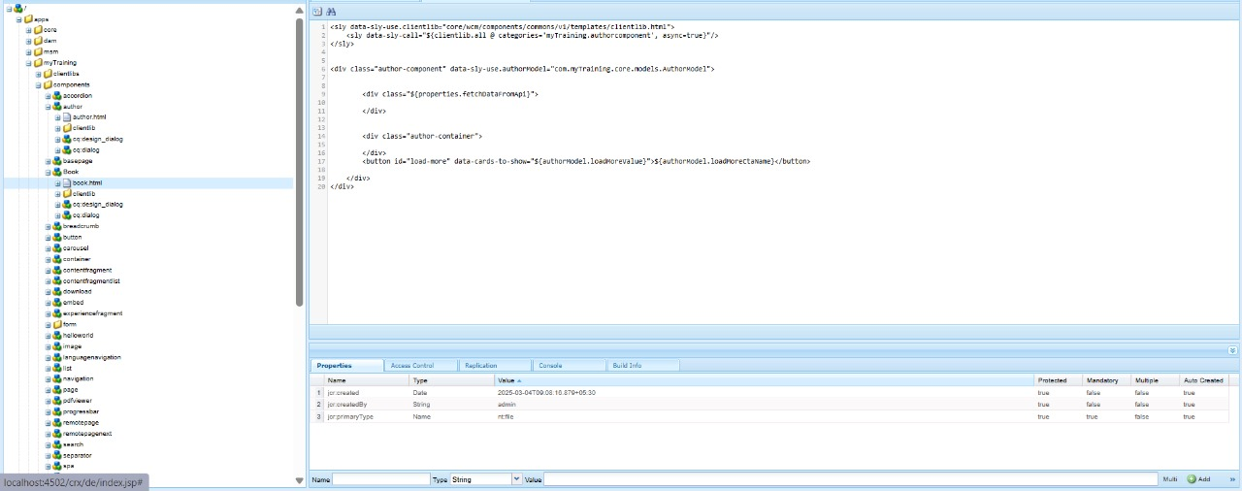

STEP5: BookModelImplementation(sling)

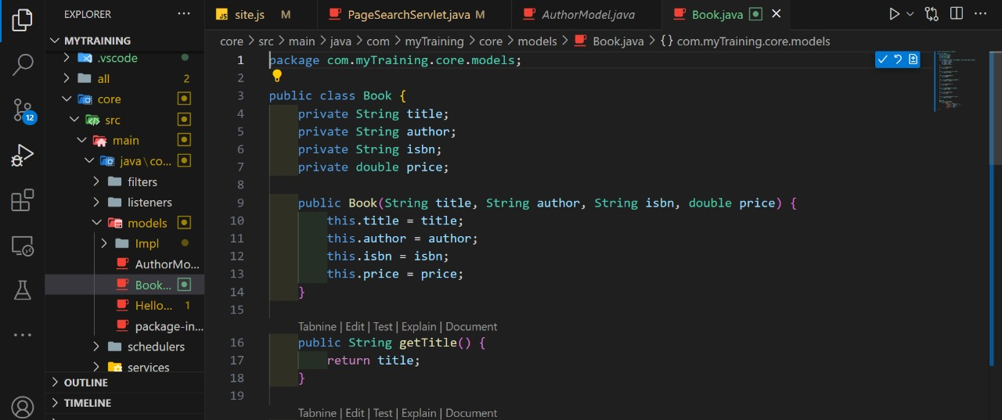

STEP 6: JSON file (Third party API) for books

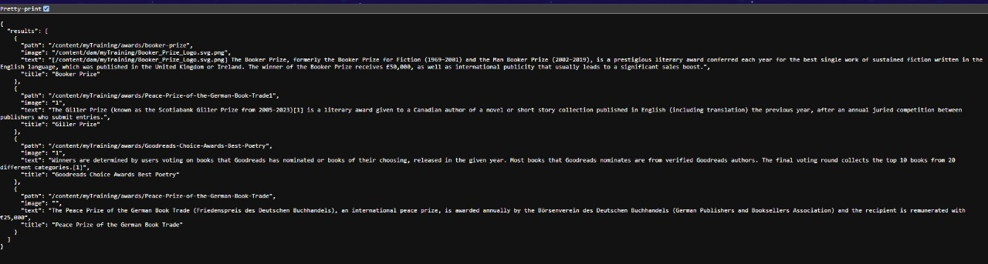

OUTPUT:

AUTHOR WEBSITE:

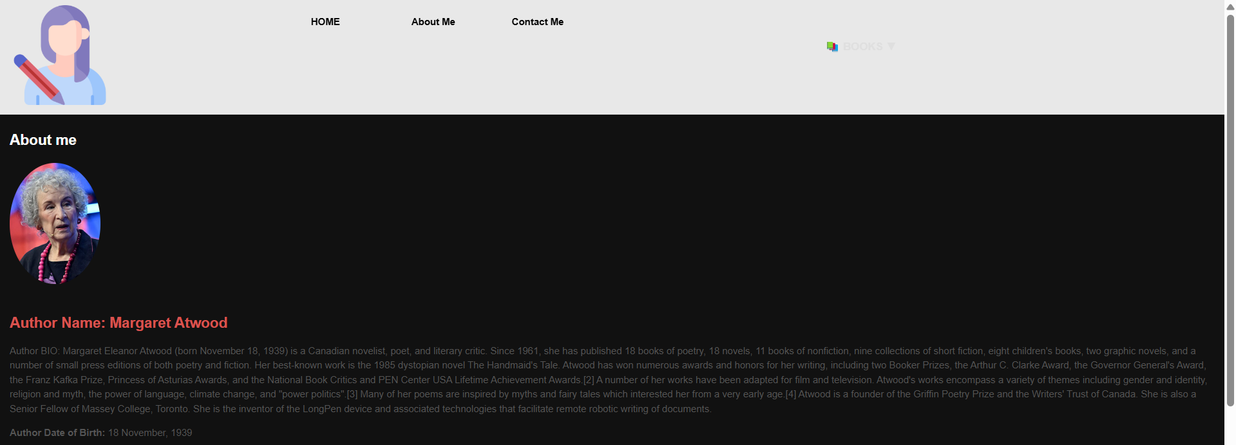

HOME PAGE:

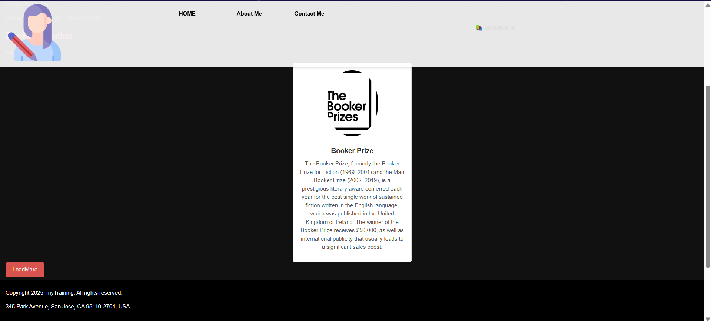  
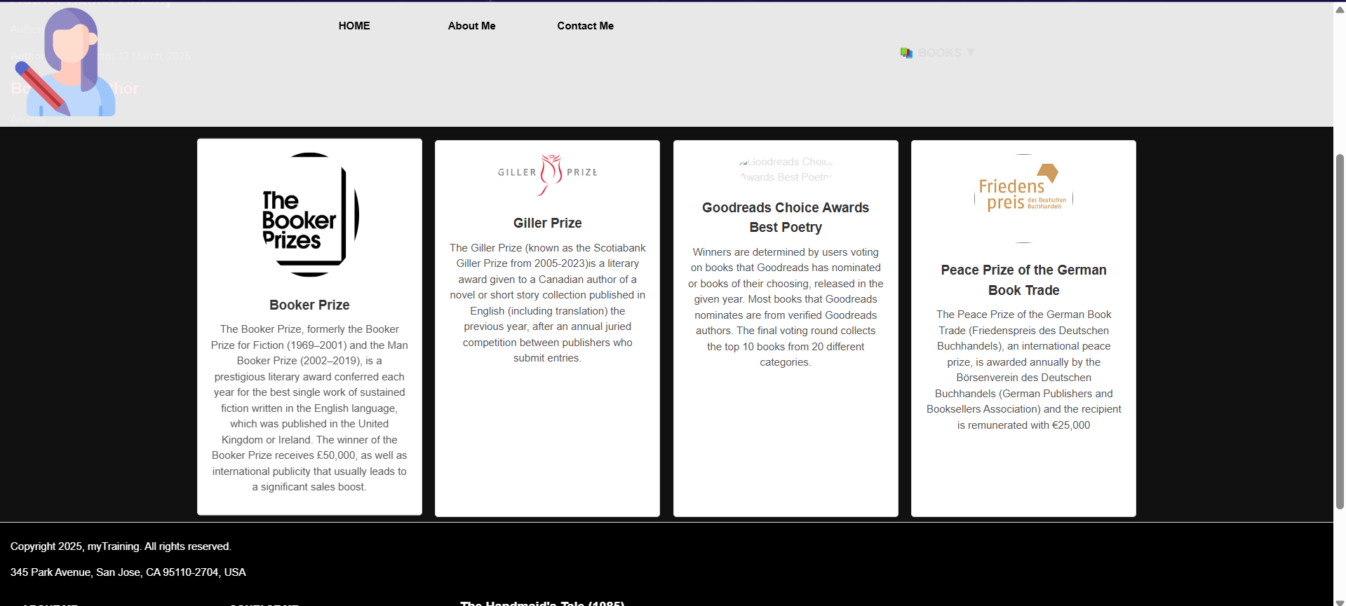

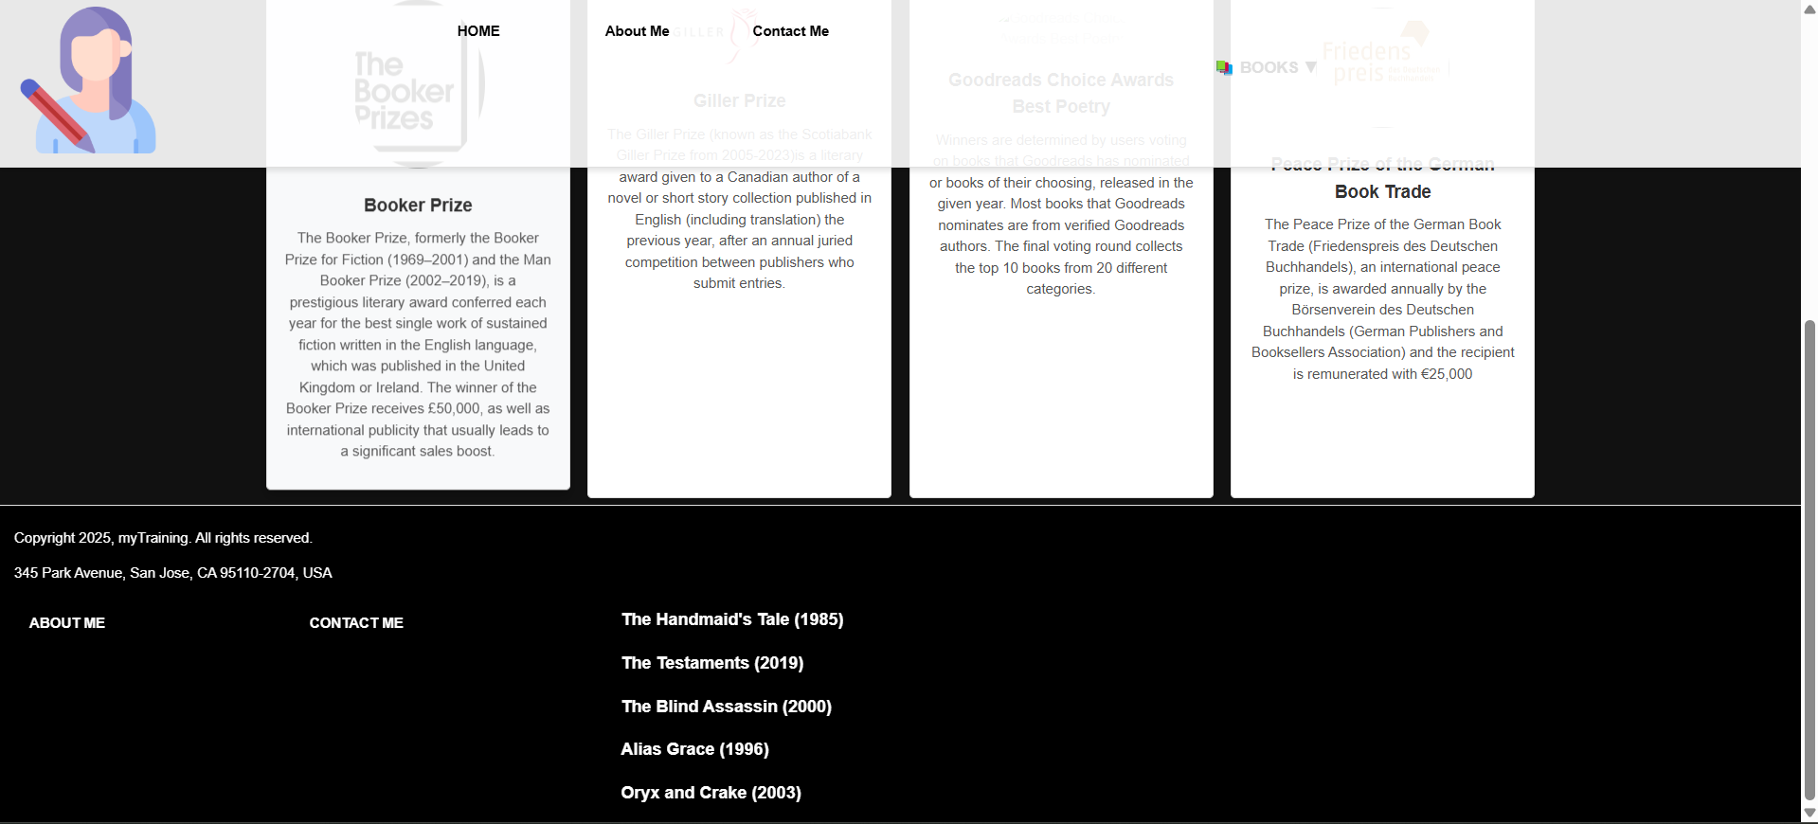

AWARD PAGE:

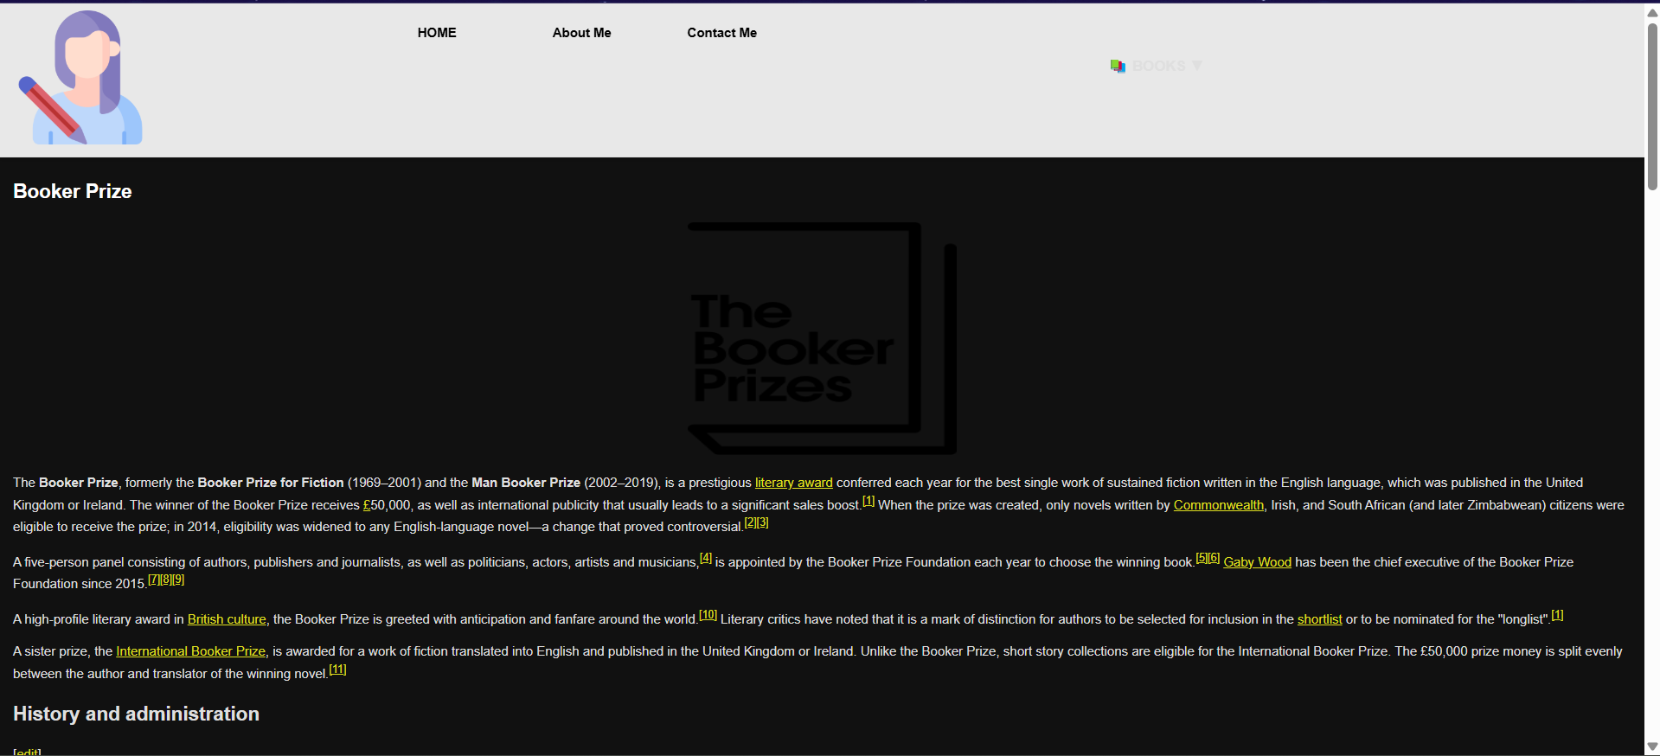

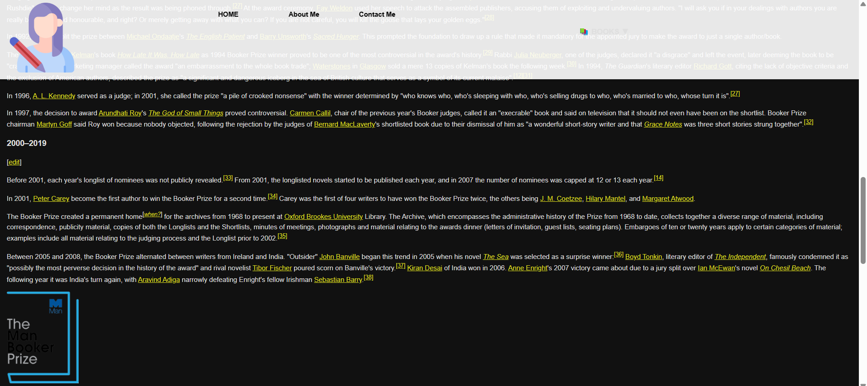

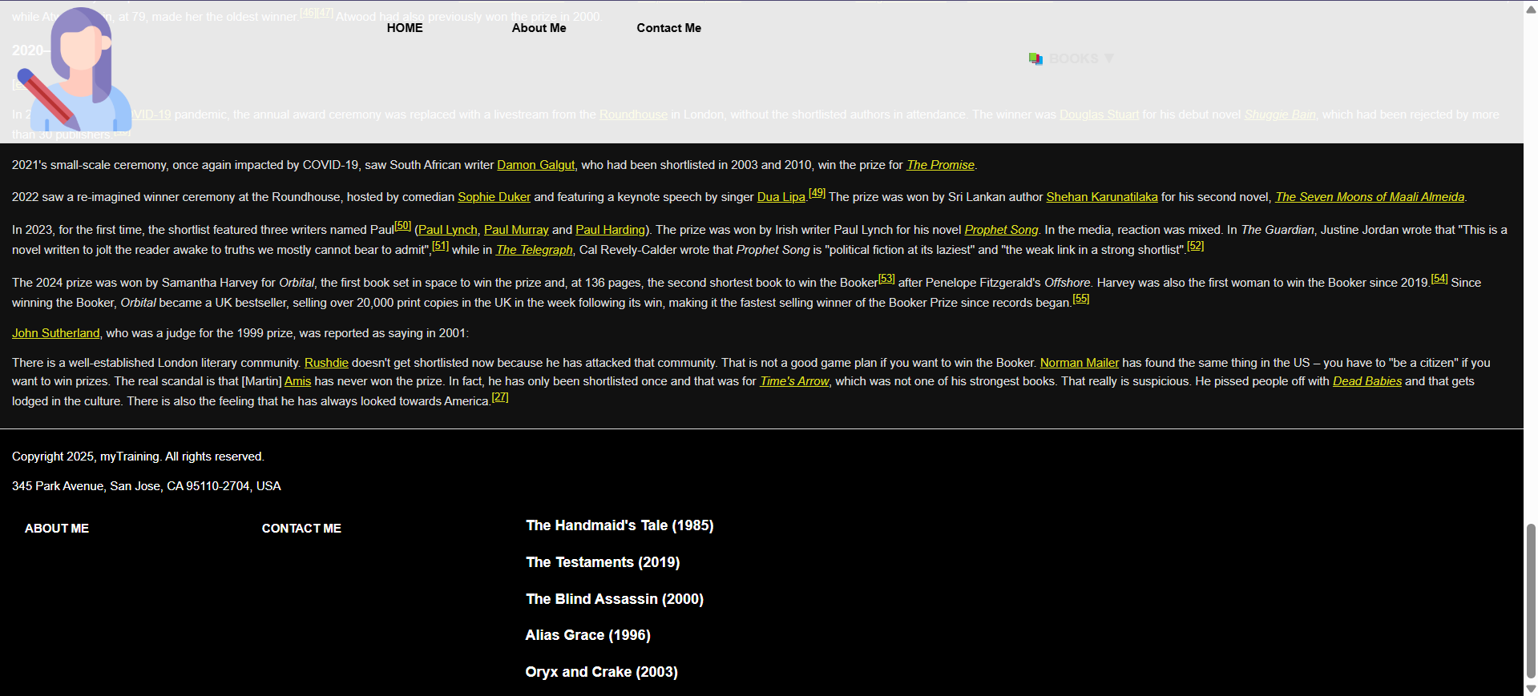

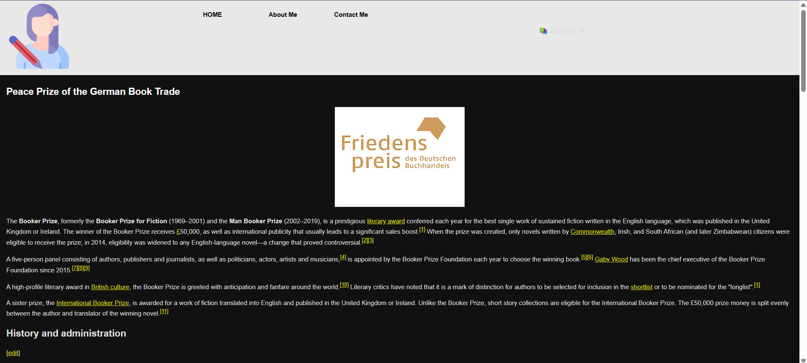

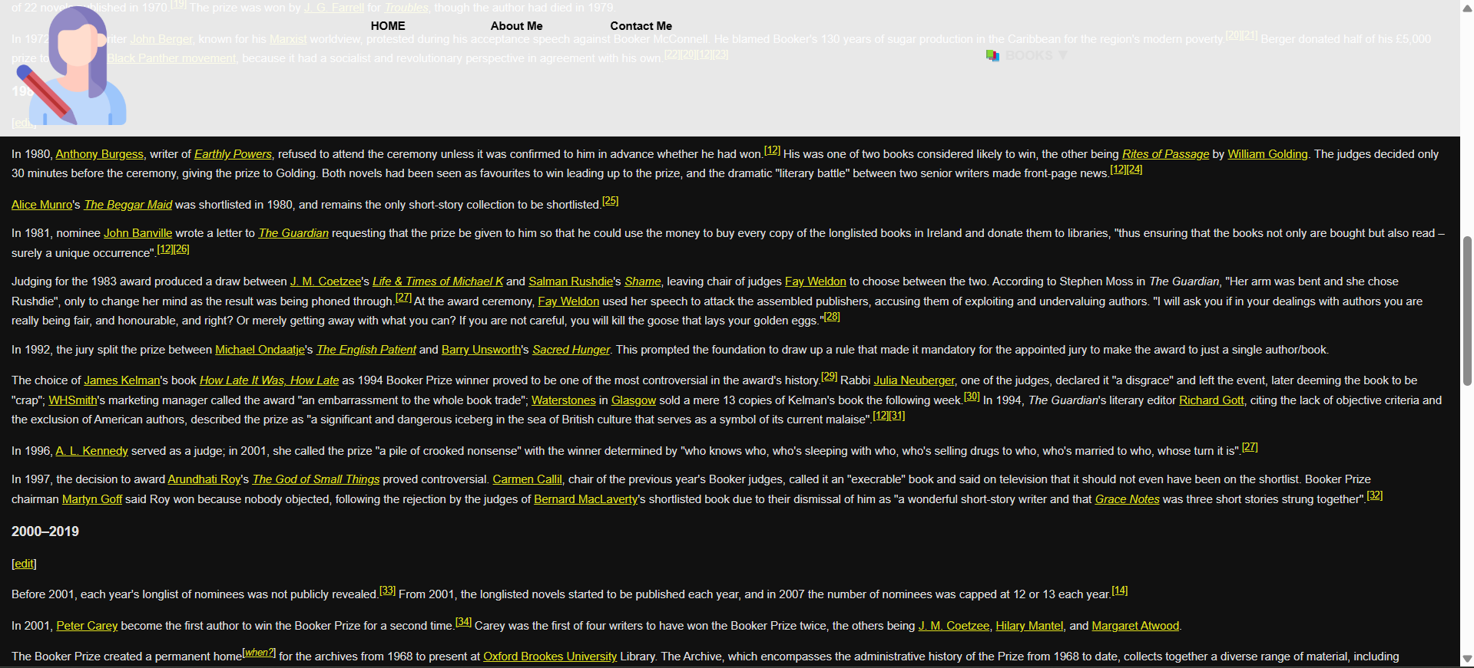

ABOUT ME:

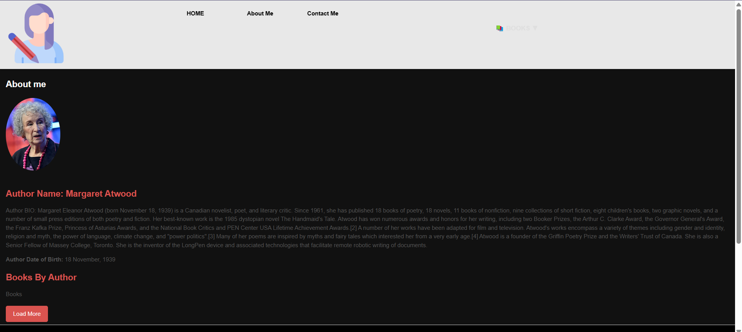

BOOKS PAGE:

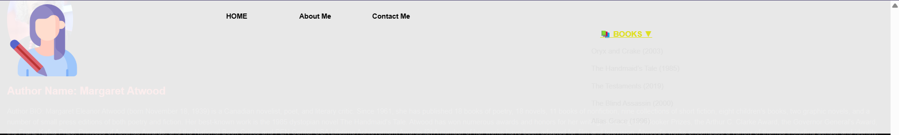

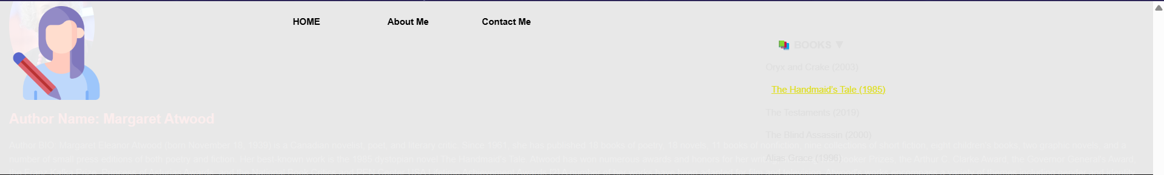

Book Page:

